**Name: HARNAM KAUR**

**Enrolment No: 00423207218**

**Class: CSE1**

**MACHINE LEARNING LAB (EXPERIMENT NO 3)**

# AIM:

ESTIMATE THE ACCURACY OF DECISION CLASSIFIER ON BREAST CANCER DATASET USING 5 FOLD CROSS VALIDATION.

# ALGORITHM:

1. Select the best attribute using Attribute Selection Measures (ASM) to split the records.
2. Make that attribute a decision node and breaks the dataset into smaller subsets.
3. Starts tree building by repeating this process recursively for each child until one of the conditions will match:
   1. All the tuples belong to the same attribute value.
   2. There are no more remaining attributes.
   3. There are no more instances.

# PROGRAM CODE SNIPPET:

## LOADING DATA SET:

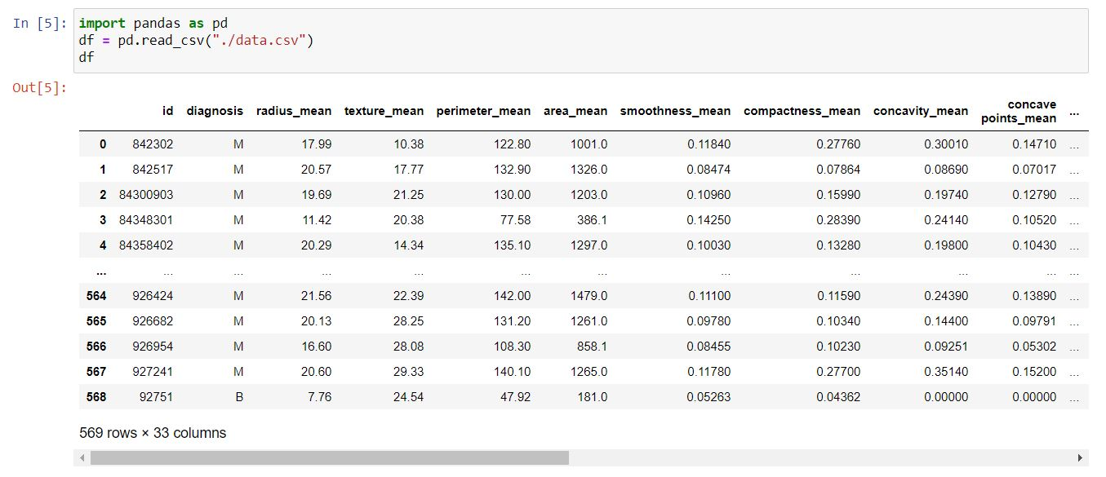

## PREPROCESSING:

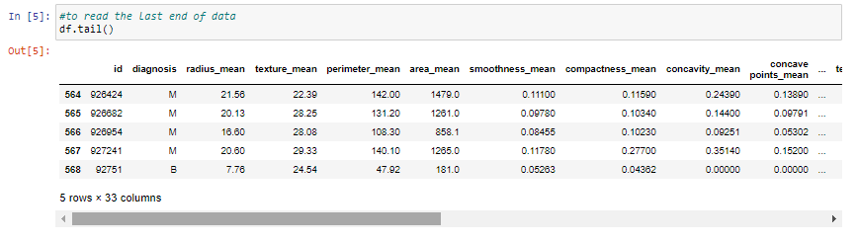

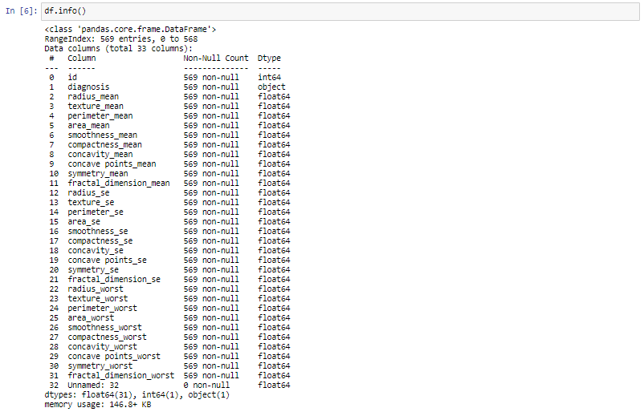

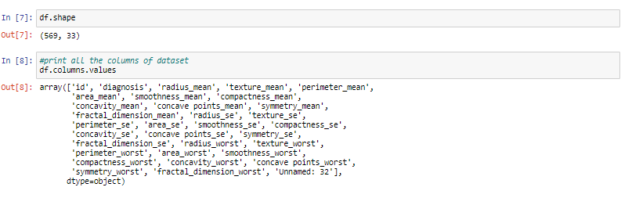

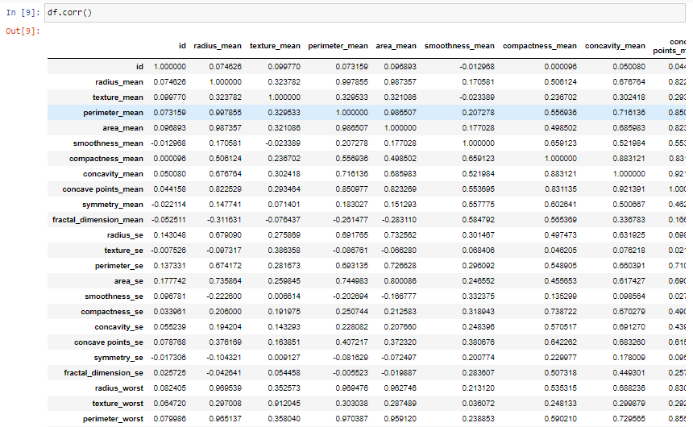

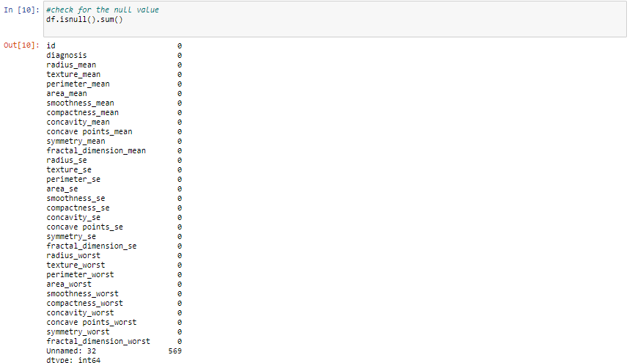

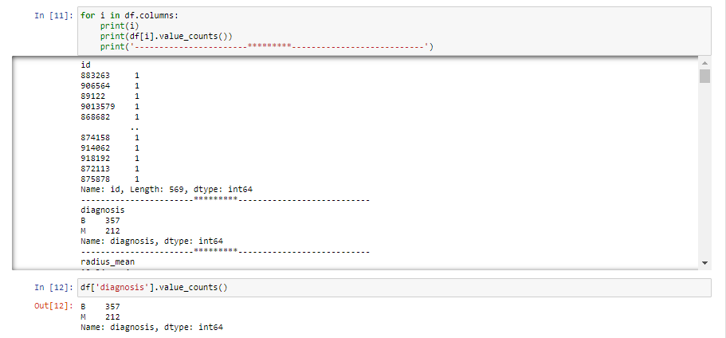

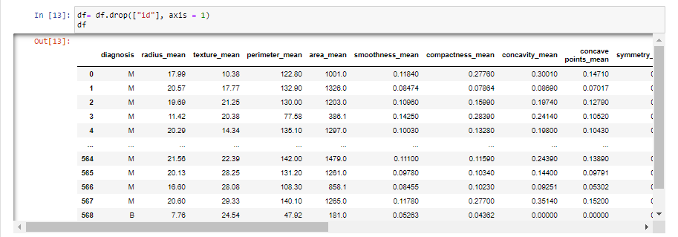

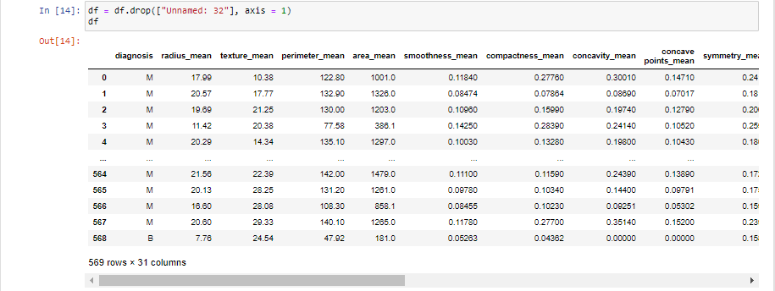

## VISUALIZATION:

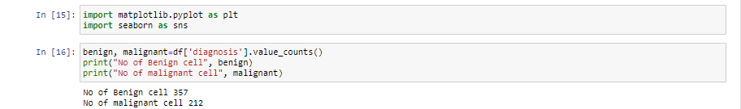

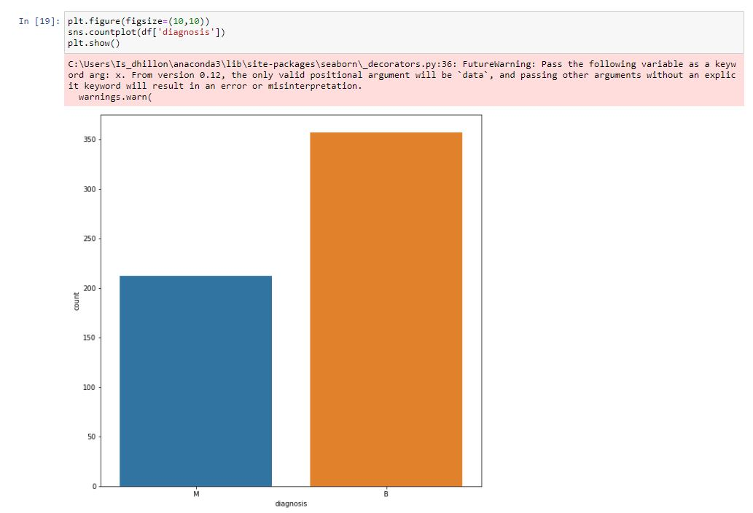

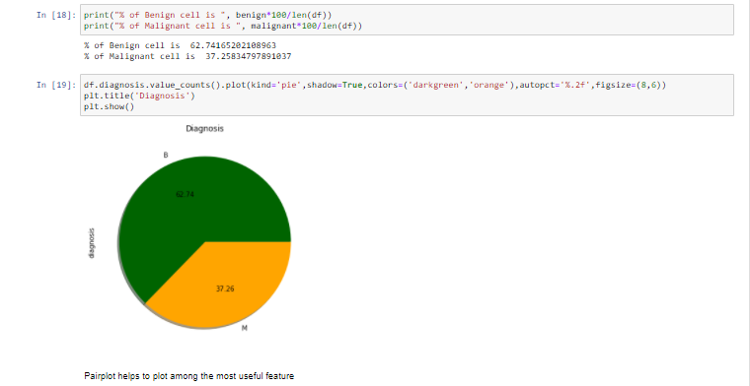

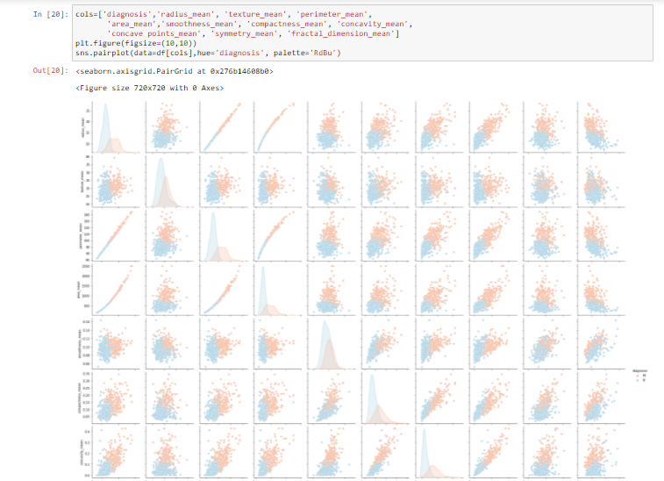

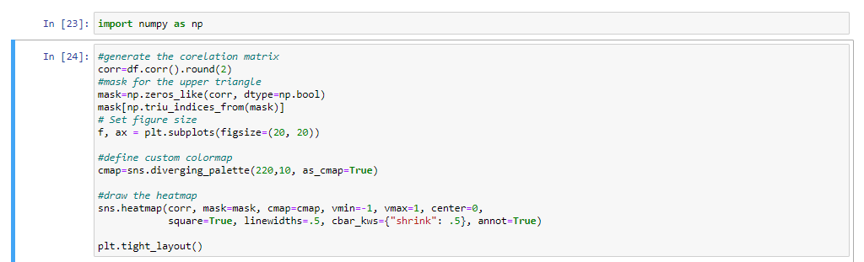

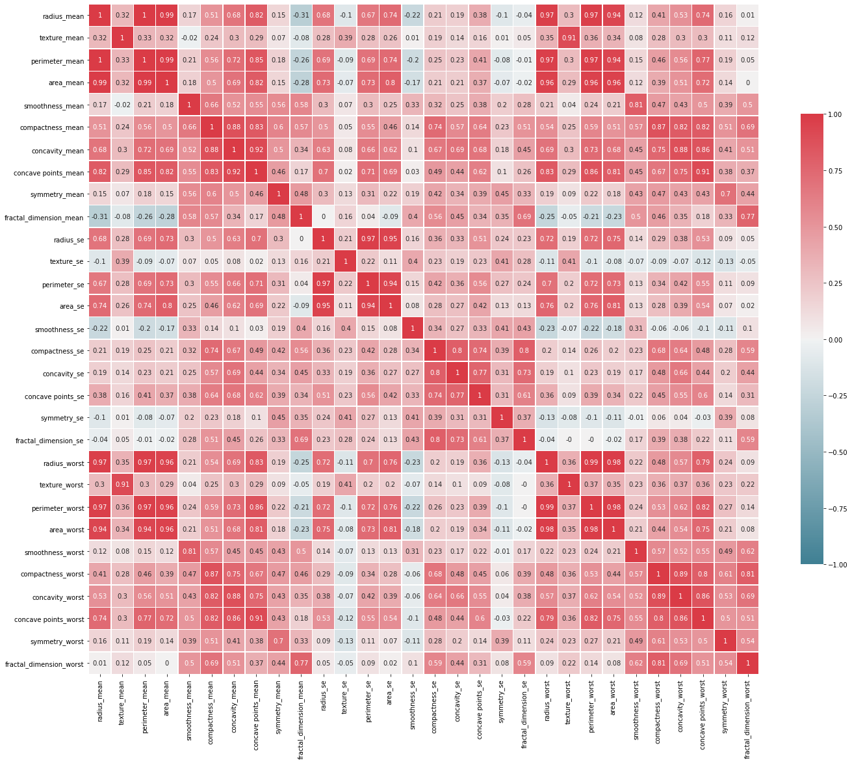

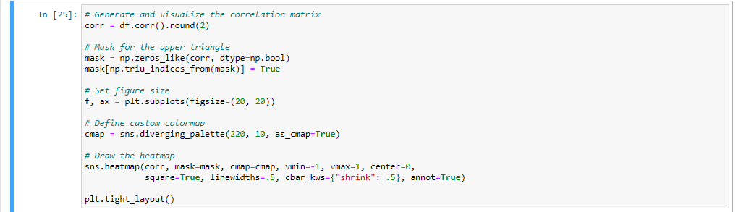

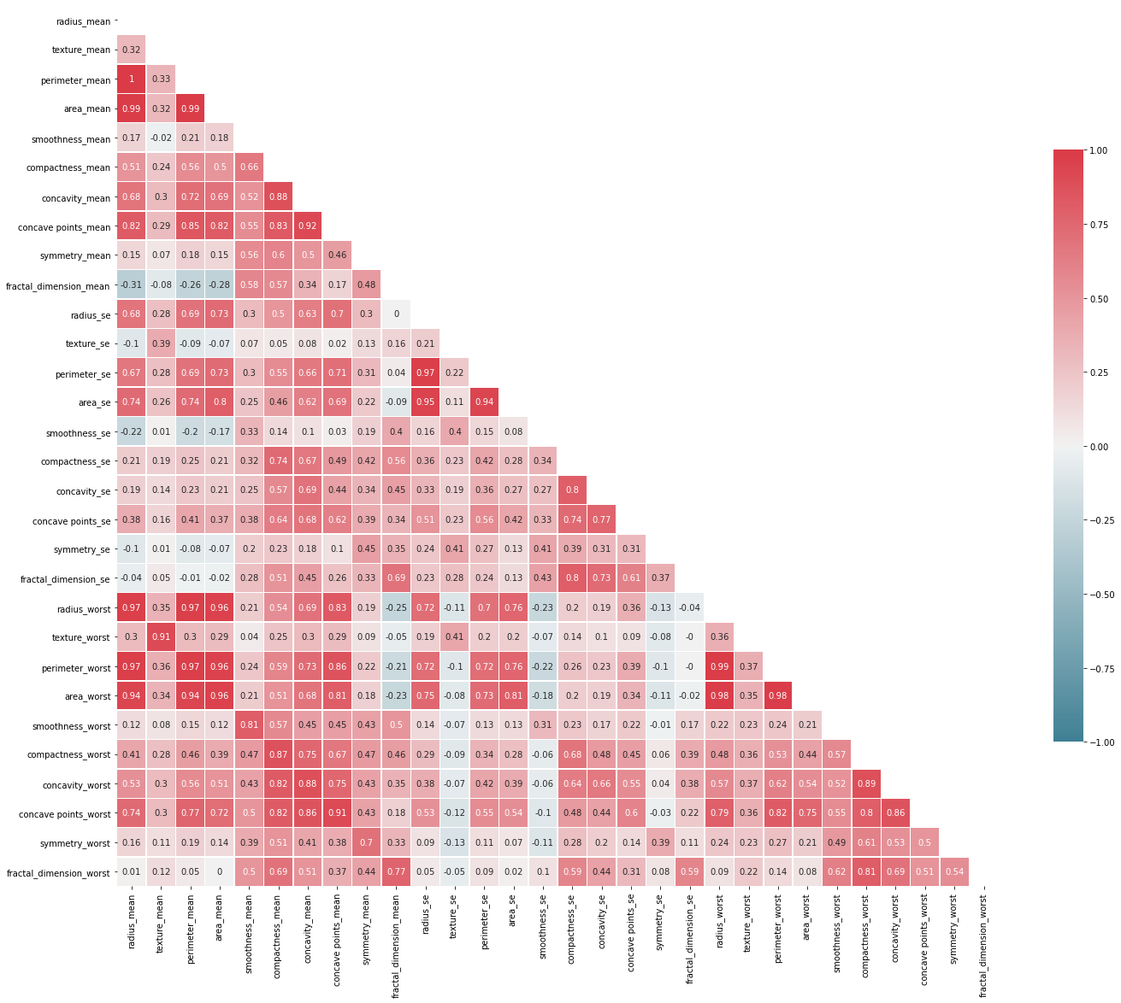

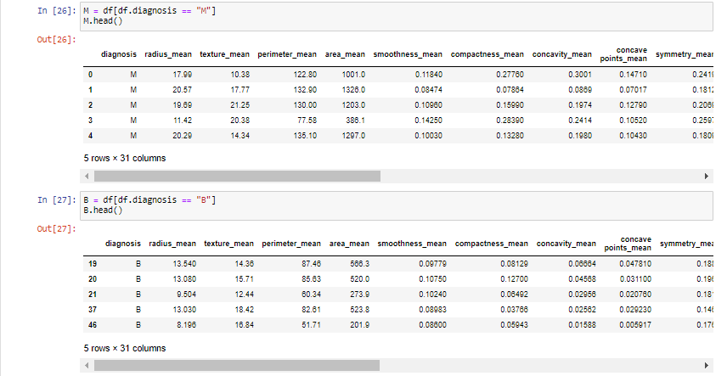

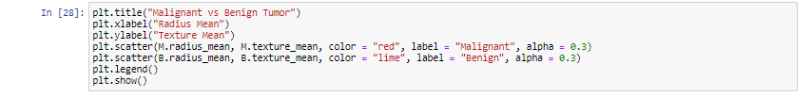

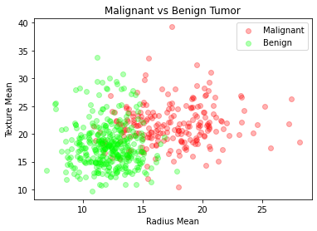

## ML ALGORITHM IMPLEMENTATION:

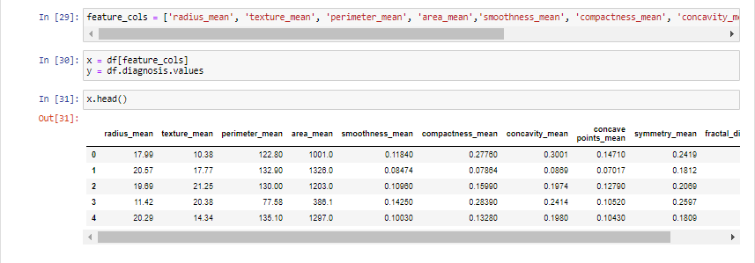

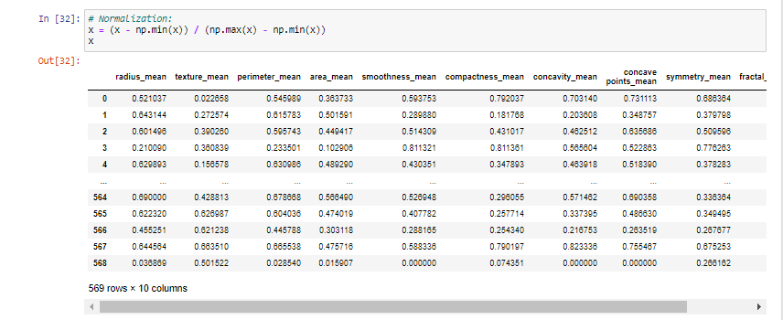

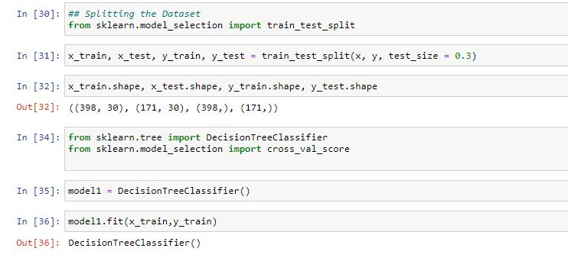

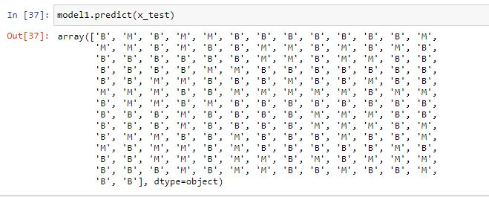

## FINAL RESULT:

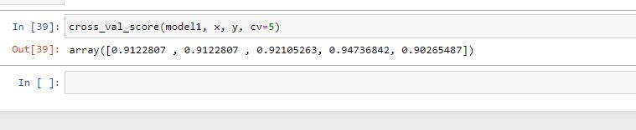

# GITHUB LINK:

<https://github.com/Harnam99/Program-3.git>